ANDRAGOGY
Timeline in History
Malcolm Knowles Mind-Map

Introduction of Andragogy
Universidad Mariano Gálvez
Licda. Maria Elena Álvarez

Marjorie Magaly Rivas Chacón
076-04304
Guatemala, February 23rd. 2015

CONTENT

ABSTRACT 3

Timeline Andragogy History 4

MIND-MAP 5

ABSTRACT
In this document I prepared a Timeline in History of Andragogy. Andragogy term was used for the first time in 1833 by a German Teacher named Alexander Kapp. Although it wasn’t used for decades, in 1921 it was picked up again and finally it was popularized in 1980 by Malcolm Knowles.
Malcolm Knowles wrote a theory about Adults Learning and presented four assumptions to show the differences between Pedagogy and Andragogy, settling that Adults learn in a completely different way than children, and this is exactly what Andragogy studies. Andragogy is the art and science to teach adults while Pedagogy is the art of teaching children.
In this document it is included a mind-map which shows the most important information about Malcolm Knowles work and theory; this helpful advice, is a great tool for all educators nowadays.

Timeline Andragogy History

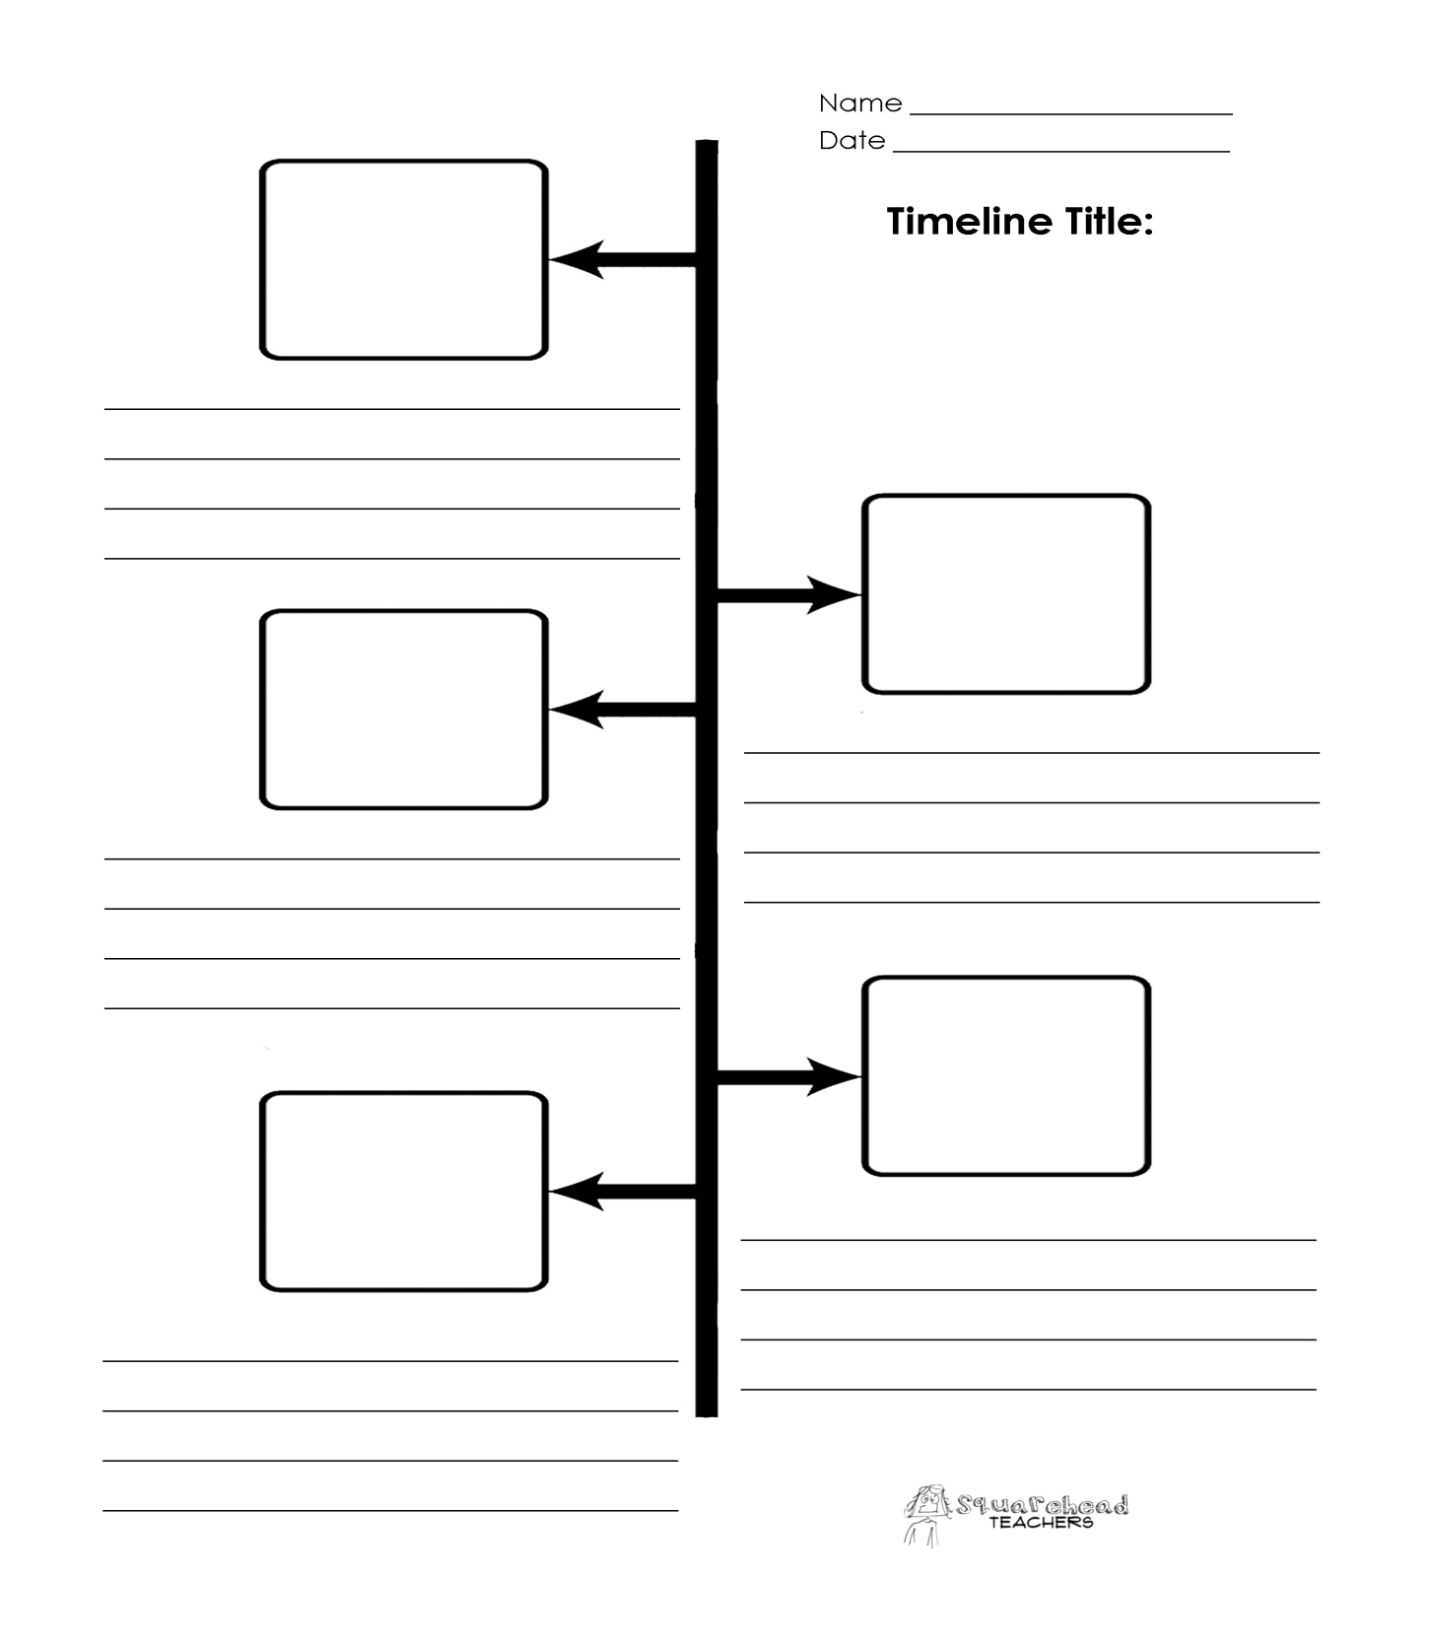
Timeline
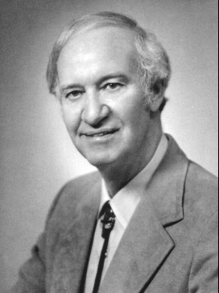
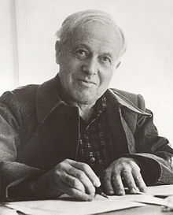
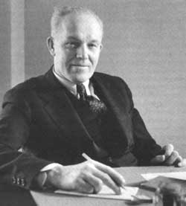
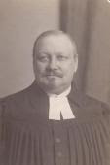
1921 - The German educator
Rosenstock Huessy
pick the term up again
and used it in special
education for adults
1980 - Malcolm Knowles popularized
the term and described his thought
about adult learning. At this time
he presented his theory based in
6 assumptions.
1926 - Eduard Lindeman introduced
the term for English speakers
and enphatized it as a teaching method
for teaching adults
1833 - The German educator
Alexander Kapp
used the term for the first time
when he tried to define the
teaching platonic ideas

MIND-MAP
Mind-Map

Abdicated the
Self-Directed Learning
Introduced the
Learning Contracts
Popularized the
term Andragogy
Claim to
Fame for

They have prior
experience which
is a good resource
for their learning
Adults are
Self-Directed
Learners.
They work in
Independence

His Four
Assumptions
Malcolm
Knowles
They have a
desire to
develop
competency
They learn when
they think they
"need to learn"
work with
life-experience
problems
Make learning
a mutual
responsibility
Use methods that
draw on learners'
prior knowledge
Include learners
in problem
solving
Involve learners
in the planning
of learning
Help them
diagnose their
learning need
Respect, support
and accept your
students the way
they are
Make your
students feel
at ease
To Do's for
Educators

